Polyhedrons
Here is a football:
WE NEED A PICTURE OF A FOOTBALL

Flatten each face and we have a polyhedron.
WE NEED A DIAGRAM

Euler’s Formula:
applies to any planar graph. It also applies to any polyhedron.
Here is a cube and we can represent it by a planar graph:
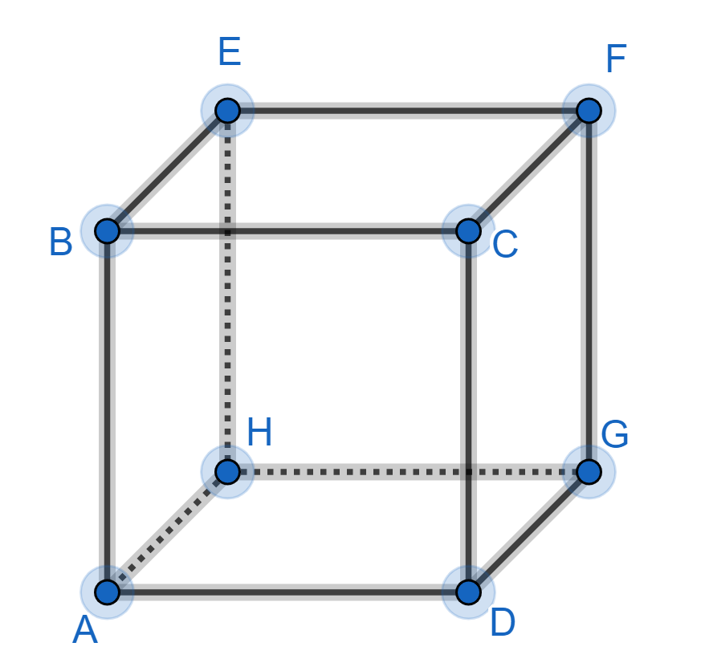
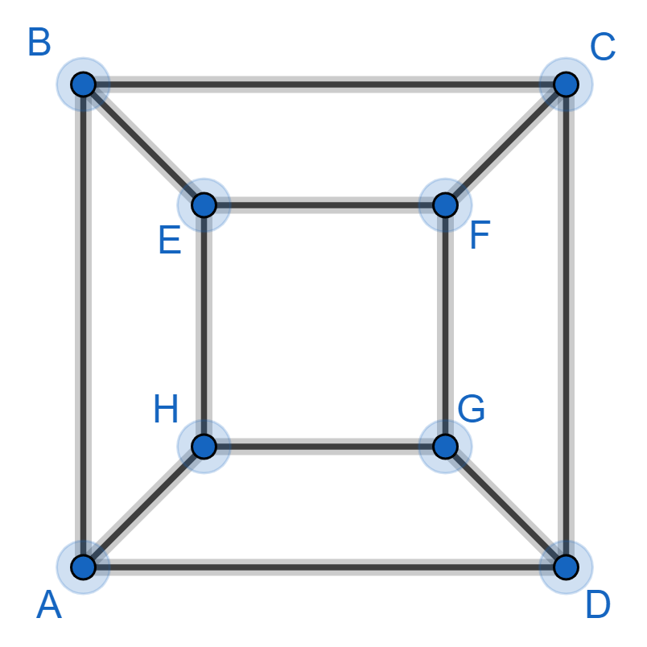

The cube has 8 vertices, the graph has 8 vertices. The cube has 12 edges, the graph has 12 edges.
The cube has 6 faces, the graph has 6 faces.
The faceon the cube corresponds to the faceon the planar graph. etc
The faceon the cube corresponds to the outside face on the planar graph.
The cube and the planar graph have their vertices connected in the same way.
So the Euler formula must apply to the cube just as it applies to the planar graph.

Interior angles:
A cube has 6 faces. Each face has 4 interior angles. Each interior angle is
So the sum of all the interior angles of a cube is
Theorem
For any polyhedron

Proof
See footnote 1

Let’s check this out for the cube:
soas expected
Gaps:
Look at the football polyhedron. At each vertex, a regular pentagon and two regular hexagons meet.
If you put a regular pentagon and two regular hexagons together on a flat table then there is a gap:
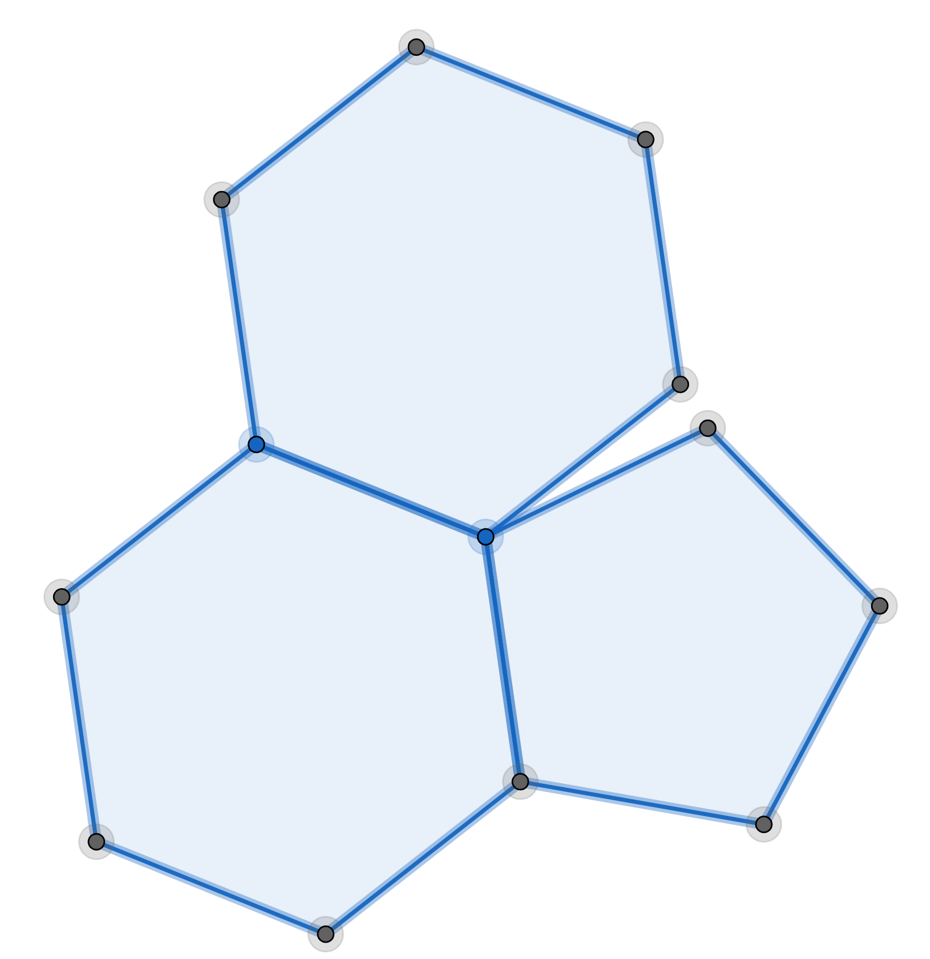

Each interior angle of a regular pentagon is
Each interior angle of a regular hexagon is
So:

So:

Descartes’ theorem
Take any polyhedron. Find the gap at each vertex. The sum of all these gaps will be 720°
Proof
see footnote 2
Example 1
A polyhedron has 3 regular pentagons meeting at each vertex. How many vertices are there?
so
Now:
so this polyhedron has 20 vertices.
Example 2
A polyhedron has 2 regular pentagons and a square meeting at each vertex. How many vertices are there?
so
Now:
so this polyhedron does not exist.

The regular polyhedrons.
Look at this cube:

This is a regular polyhedron because:
All the faces are identical.
All the faces are regular polygons.
All the vertices are surrounded by the same number of faces.
Theorem
There are only 5 regular polyhedrons
Proof
Consider a regular polyhedron where each face hassides andfaces meet at each vertex.
Note:
andCan you see why?

Ifandthen three triangles meet at each vertex.
soandso we have 4 vertices

Ifandthen four triangles meet at each vertex.
soandso we have 6 vertices

Ifandthen five triangles meet at each vertex.
soandso we have 12 vertices

Ifandthen three squares meet at each vertex.
soandso we have 8 vertices

Ifandthen three pentagons meet at each vertex.
soandso we have 20 vertices

Ifandorandorandorand
then you can easily check that the gaps are zero or negative and this is no good.
So there are only these 5 possibilities.
Example 3
Let’s check out theandpolygon.
We knowWhat aboutand?
Three faces meet at each vertex, so 3 edges meet at each vertex.
So No!
Each edge is shared with 2 vertices.
So
But so
This polyhedron is called a dodecahedron.

see Exercise 1

The semi-regular polyhedrons.
Look at the football polyhedron:
This is semi-regular polyhedron because:
All the pentagons are identical
All the hexagons are identical.
All the faces are regular polygons.
All the vertices are surrounded by the same set of faces in the same order.
Theorem
There are only 13 semi-regular polyhedrons.
We will not prove this and we will not try to find them all.
But let’s see if we can find some.
Example 4
Let’s check out the football polyhedron.
One pentagon and two hexagons meet at each vertex.
and SoWhat aboutand?
Three faces meet at each vertex. So 3 edges meet at each vertex.
SoNo!
Each edge is shared with 2 vertices.
So
ButSo
We have 32 faces.pentagons andhexagons.
One pentagon meets at each vertex.
SoNo!
Each pentagon joins five vertices.
So
Two hexagons meet at each vertex.
SoNo!
Each hexagon joins six vertices.
So
Check:Good!

WARNING
We have been a bit sloppy.
SEE NOTES IN LEVER ARCH FILE

There are some polyhedrons, called prisms and anti-prisms, that seem to fit the description of a semi-regular polyhedron but are not included in the 13 semi-regular polyhedrons – check them out
see Exercise 2
see Exercise 3
EXERCISE 1
Check out the other 4 regular polyhedrons
EXERCISE 2
1) Can you find a semi-regular polyhedron where one triangle and two hexagons meet at each vertex?
2) Can you find a semi-regular polyhedron where one square and two pentagons meet at each vertex? CHANGE THIS – SAME AS EXAMPLE 2

EXERCISE 3
Use the pigeon-hole principle to show that you cannot have a polyhedron where every face has a different number of edges.
SOLUTIONS 1
tetrahedron
octahedron
icosahedron
cube
SOLUTIONS 2
1) andSo
Three faces meet at each vertex. So 3 edges meet at each vertex. SoNo!
Each edge is shared with two vertices. So
ButSo
We have 8 faces.triangles andhexagons.
One triangle meets at each vertex. SoNo!
Each triangle joins three vertices. So
Two hexagons meet at each vertex. SoNo!
Each hexagon joins six vertices. So
Check:Good!
2) and So this is no good! CHANGE THIS – SAME AS EXAMPLE 2

SOLUTIONS 3
A polyhedron has 10 faces.
I have 7 boxes, labelled 3, 4, 5, 6, 7, 8, 9. I put each face in a box.
If a face has 7 edges then I put it in the box with 7 on the label. etc
There are 7 boxes and 10 faces. One (or more) box must contain two (or more) faces.
So two (or more) faces have the same number of edges.
note: each face has at least 3 edges
note: there are only 10 faces so a face cannot have 10 or more edges because each edge is connected to another face.
This proof will work however many faces the polyhedron has.

Footnote 1
Interior angles rule
Let’s find the sum of all the interior angles of any polyhedron.
The first face of our polyhedron hassides.
The interior angles of this face add up to (remember?)
The second face of our polyhedron hassides.
The interior angles of this face add up to
etc
There arefaces
So:

Now:
No!
Each edge is shared with two faces.
So:
So
So:

Now:
so
So:

Footnote 2
To findwe looked at the faces of our polyhedron.
We looked at the faces of a cube and said:
A cube has 6 faces. Each face has 4 interior angles. Each interior angle is
So the sum of all the interior angles of a cube is
In general, we proved:

by finding the sum of the interior angles of each face and then adding these up.

An alternative approach
We will look at the vertices of our polyhedron.
We look at the vertices of a cube and say:
A cube has 8 vertices. Each vertex is surrounded by 3 interior angles. Each interior angle is
So the sum of all the interior angles of a cube is
We will use this approach to prove Descartes’ theorem.

At each vertex:

So if we visit each vertex and add up all these angles:

Now:
andso

